Chapter 3, Solution 10

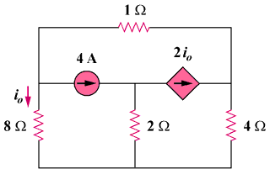

v₃

v₂

v₁

At node 1. [(v₁–0)/8] + [(v₁–v₃)/1] + 4 = 0

At node 2. –4 + [(v₂–0)/2] + 2i_{o} = 0

At node 3. –2i_{o} + [(v₃–0)/4] + [(v₃–v₁)/1] = 0

Finally, we need a constraint equation, i_{o} = v₁/8

This produces,
1.125v₁ – v₃ = –4 (1)

0.25v₁ + 0.5v₂ = 4 (2)

–1.25v₁ + 1.25v₃ = 0 or v₁ = v₃ (3)

Substituting (3) into (1) we get (1.125–1)v₁ = –4 or v₁ = –4/0.125 = –32 volts. This leads to,

i_{o} = 32/8 = –4 amps.

